InfoServer
GPS-Disciplined Stratum-1 Network Time and Information Server
Assembly Manual

July 2026
This manual describes the assembly, bring-up, and testing of the InfoServer from a bare PCB and components — a self-contained network time server that derives time from a GPS receiver (or an upstream Internet time server), disciplines a temperature-compensated DS3231 real-time clock to that source, and serves it to NTP clients on the local network.
Revision/Update Information: | Document Revision 1.2
Hardware Revision: | 2
Companion Firmware Version: | 1.5
Designed by Mitchell Feig
Copyright © 2024–2026 Mitchell Feig

Table of Contents

1. Introduction 1-1
2. Safety Warnings 2-1
3. Required Tools and Equipment 3-1
4. Assembly Sequence 4-1
5. Initial Power-On and Testing 5-1
6. Troubleshooting 6-1
Appendix A — Bill of Materials A-1
Appendix B — Schematic and Wiring Reference B-1

1. Introduction

This manual covers the assembly, bring-up, and testing of the InfoServer from a bare PCB and components. The InfoServer is a stratum-1 network time server built on an ESP32-S3: it derives time from a u-blox GPS receiver (NMEA plus a 1PPS one-pulse-per-second edge), disciplines a temperature-compensated DS3231 real-time clock to that source, and serves the result to NTP clients on the local network. A 74HCT14 level shifter drives a four-LED APA102 string — two status indicators and two under-lights — on the FSPI hardware-SPI bus.
The board is a single mixed-technology assembly. Its functional blocks are:
- Power and USB — 5 V USB-C input and the 3.3 V rail for the ESP32-S3.
- Processor — the ESP32-S3-WROOM-1 module, the SW1 button, and the EN reset button.
- Timekeeping — the DS3231 RTC with its coin-cell backup and I²C pull-ups.
- GPS — the u-blox receiver with its NMEA serial link, 1PPS edge, and reset line.
- LEDs — the 74HCT14 level shifter and the four-LED APA102 string.
Unlike a high-voltage build, the InfoServer runs entirely from 5 V USB-C and a 3.3 V rail — there is no lethal voltage anywhere on the board. The assembly is still fine-pitch surface-mount work, so the order in Section 4 is chosen to make the hardest parts easiest. The GPS module is installed first, while the board is still bare and fully accessible; after that, part order does not matter.
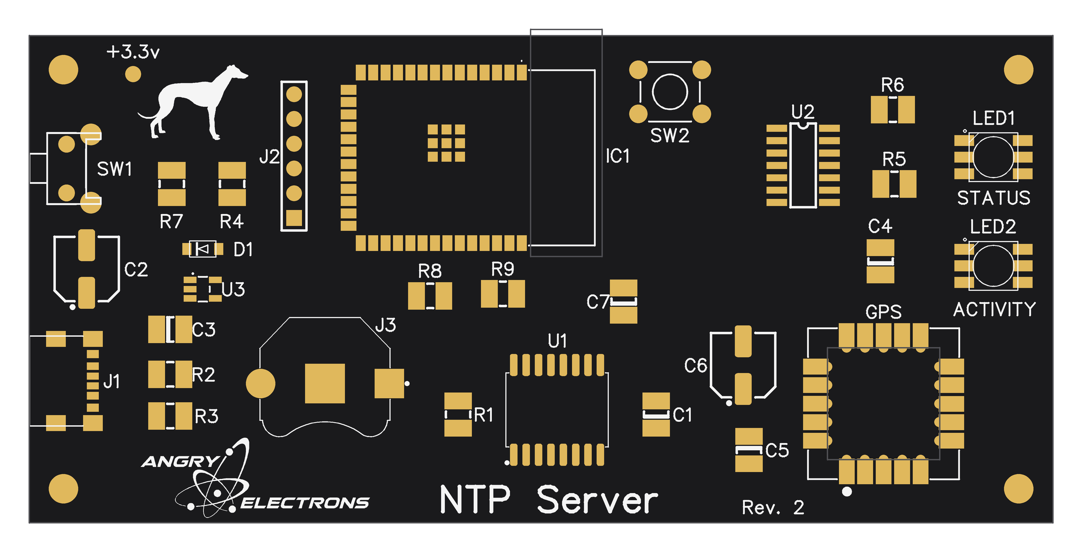
Figure 1 — Top-side component placement (Rev. 2 silkscreen). IC1 is the ESP32-S3 module; the GPS receiver is at the lower right.

2. Safety Warnings

CAUTION: This board contains static-sensitive devices (the ESP32-S3 module, the GPS receiver, the DS3231, and the 74HCT14). Work at an ESD-safe station and wear a grounded wrist strap before handling any component.
CAUTION: The GPS receiver and the ESP32-S3 module are fine-pitch parts with a polarity/pin-1 marking. Installing either one rotated will damage it on power-up. Confirm the pin-1 dot before applying the iron, and confirm pin alignment again before applying power.
CAUTION: Observe correct polarity on the coin cell and on any electrolytic capacitors. A reversed coin cell can damage the DS3231; a reversed electrolytic can vent or fail.
CAUTION: Power the finished board only from a standard 5 V USB-C source. Do not feed any higher voltage into the USB-C connector or the 5 V rail.
NOTICE: If for any reason the conditions above and the copyright notice at the end of this manual cannot be met, return the kit or assembled unit in original condition within 30 days of purchase for a full refund, less shipping.

3. Required Tools and Equipment

Soldering
- Temperature-controlled soldering iron with a fine conical or chisel tip (recommended 330–350°C / 625–660°F)
- Fine solder (0.5–0.8 mm rosin-core, 60/40 or lead-free)
- Liquid or gel flux (essential for the GPS module and the ESP32-S3 module)
- Solder wick and a desoldering pump
- Fine-tip tweezers for SMD components
- Magnifying visor or bench microscope
Test Equipment
- Digital multimeter (continuity and DC volts)
- 5 V USB-C power supply and cable
- Phone or computer with Wi-Fi and a web browser (for first-boot setup)
Hand Tools
- Flush cutters
- Anti-static wrist strap

4. Assembly Sequence

Install the GPS module first, while the board is bare and every pad is easy to reach. After the GPS module is in place, the remaining parts may be installed in any order — there is no required sequence for the rest of the board. Use Figure 1 (Section 1) to locate each reference designator, and inspect every joint under magnification as you go.

4.1 Step 1: GPS Module (install first)
The GPS module (lower right of the board, labeled GPS — the u-blox SAM-M10Q) is installed before anything else so that no neighboring components block access to its pads or trap heat. Take your time aligning it — a rotated or skewed module is the one mistake that is hard to undo later.
Align and tack
1. Orient the module so the pin-1 dot on the GPS module lines up with the dot marked on the board. Do not rely on the outline alone — match the dots.
2. Slightly wet a single pin at the top of the board with the iron, then tack that one pin in place from the bottom of the board. Use just enough solder to hold the module — this joint is only a temporary anchor.
3. Before soldering anything else, check that every remaining pin is in perfect alignment with its pad. Sight down each row. If the module is skewed or shifted, re-melt the single tacked joint and nudge the module true, then re-check.
4. Only once all pins are confirmed in perfect alignment, solder the remaining pins. Reflow the original tack joint last so it matches the rest.
CAUTION: Verify the pin-1 dot alignment before tacking and verify full pin alignment before soldering the rest. A module soldered rotated must be removed with hot air — there is no easy fix once all pins are down.

4.2 Step 2: Microcontroller (IC1, ESP32-S3 module)
Install the ESP32-S3-WROOM-1 module (IC1, center of the board) using the same technique as the GPS module.
1. Orient the module so its pin-1 / keep-out marking matches the silkscreen on the board.
2. Solder a single pin in place to tack the module down.
3. Carefully check that all pins line up with their pads. If anything is off, re-melt the one tacked joint and correct the position before continuing.
4. Once alignment is confirmed, solder the remaining pins.

4.3 Remaining Components (any order)
With the GPS module and IC1 in place, install the rest of the board in whatever order is convenient. Each small IC has its own pin-1 / keep-out mark — verify it against the silkscreen before soldering, the same as for IC1. Observe the orientation notes below for the keyed and polarized parts.
Small ICs and diode (U1, U2, U3, D1)
1. U1 — DS3231S RTC (SOIC-16). Verify the pin-1 mark against the silkscreen.
2. U2 — 74HCT14 level shifter (SOIC-14). Verify the pin-1 mark.
3. U3 — AP2112K-3.3 V LDO regulator (SOT-23-5), by the +3.3 V net at the upper left.
4. D1 — CDBM-140G Schottky diode. Observe the cathode band against the silkscreen.
Status LEDs and under-lights (LED1–LED4)
1. LED1 (STATUS) and LED2 (ACTIVITY) — the two APA102 indicators on the top of the board, by the right edge.
2. LED3 and LED4 — the two APA102 under-lights on the bottom of the board (see Figure 2). Each has a pin-1 dot on its corner.
CAUTION: The four APA102 LEDs are one directional chain (LED1→LED2→LED3→LED4). Install every LED with its data-in and clock-in toward the previous device, matching the pin-1 dot to the silkscreen. One reversed LED breaks the chain past that point.
Passives, buttons, connectors
1. Resistors R1–R9 and capacitors C1–C7 — including the I²C pull-ups and the reset pull-up (R1).
2. SW1 (function button) and SW2 (EN / hardware reset).
3. J2 and the coin-cell holder (J3) — observe coin-cell polarity, + side up.
4. J1 — the USB-C connector. Seat it flat and fully before soldering the shield tabs.
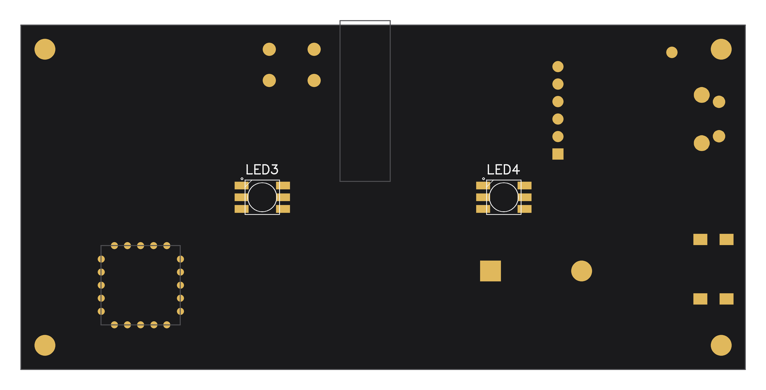
Figure 2 — Bottom-side component placement (mirrored, as seen looking at the underside). LED3 and LED4 are the under-lights.

5. Initial Power-On and Testing

Pre-Power Checks
Before applying power for the first time:
- Visually inspect every joint under magnification, especially the GPS module, the ESP32-S3 module, the DS3231, and the 74HCT14.
- Check for solder bridges on all fine-pitch packages.
- Confirm the coin cell and any electrolytic capacitors are installed with correct polarity.
- Confirm there is no short between 5 V and GND, or between 3.3 V and GND, with a continuity / resistance check.
Power-On Sequence
1. Connect a 5 V USB-C supply. Current draw should be modest with no fault.
2. Verify the 3.3 V rail reads 3.3 V ± 0.1 V.
3. On a brand-new unit the ESP32-S3 creates a Wi-Fi access point named "InfoServer" (no password).
4. From a phone or PC, join that network and browse to 192.168.4.1. At a minimum, select your home network and enter its password, choose the discipline mode (leave it on NMEA GPS), then Save and Start. The unit reboots onto your network.
5. Give the unit a clear view of the sky. A first GPS fix from a cold start can take from under a minute to several minutes.
Testing Subsystems
LEDs: the STATUS indicator pulses one short heartbeat per second, its color reporting the active source (green on GPS lock, blue on NTP lock, amber in GPS holdover); the ACTIVITY indicator flashes in that same color as NTP time requests are served, and purple as /info requests are served. In AP setup mode both LEDs alternate red. If no LED lights, check the 74HCT14, the LED series resistors, and the data/clock continuity along the chain.
Button: double-click SW1 — the unit should blink out its IP address on the LEDs, one octet at a time. Hold SW1 for ten seconds to trigger an over-the-air update check.
Time source: open the status page (the unit’s IP address, or http://infoserver.local/) and confirm Source shows GPS once a fix is acquired, and that Status reads LOCKED. The GPS−NTP figure should settle to a few milliseconds.

6. Troubleshooting

Symptom | Check | Solution
No power (nothing responds) | USB-C connector, 5 V and 3.3 V rails | Reflow the USB-C shield and power pins. Verify 5 V at the connector and 3.3 V at the regulator output.
ESP32-S3 not booting / no AP | Module solder joints, strapping pins | Reflow the module pins and check for bridges. Re-flash over USB-C if needed. Keep metal away from the module antenna.
Never gets a GPS fix | GPS module orientation, sky view, NMEA link | Confirm the pin-1 dot alignment and that all pins are soldered. Give the unit a clear view of the sky; cold starts under cover can take a long time. Source will read NTP while GPS is unacquired.
Status stuck at NO SYNC | Wi-Fi connection, discipline source | Confirm Wi-Fi is connected so the NTP fallback can work, and that the GPS or NTP source can lock. The server stays silent until it locks.
GPS−NTP shown in red | GPS reception, upstream NTP server | A persistent disagreement over one second. Suspect poor GPS reception or a bad upstream server; try the alternate NTP server.
LEDs do not light | 74HCT14, series resistors, chain continuity | Verify 5 V at the 74HCT14, check the LED series resistors, and confirm data/clock continuity from the level shifter into the first LED.
LED chain partially works | Failed or reversed LED in the chain | Data cascades — a dead or reversed LED breaks the chain past it. Replace or re-orient the first non-working LED.
RTC loses time across power loss | Coin cell, cell polarity, holder | Verify the cell voltage and that it is installed + side up. Reflow the holder contacts.
Buttons do nothing | SW1 / EN solder joints | Reflow the button pins and check continuity to the respective GPIO and GND.

Appendix A — Bill of Materials

Reference designators, parts, and values are taken from the Rev. 2 schematic and board silkscreen (see Figures 1 and 2). Quantities are for one unit.
Modules
Ref | Part | Package | Qty | Description
IC1 | ESP32-S3-WROOM-1-N16R8 | Module | 1 | Wi-Fi microcontroller; 16 MB flash, 8 MB PSRAM
ANT1 | u-blox SAM-M10Q-00B | Module (LGA) | 1 | GPS receiver with integrated antenna; NMEA + 1PPS (silkscreen label: GPS)

Integrated Circuits and Diode
Ref | Part | Package | Qty | Description
U1 | DS3231S | SOIC-16 | 1 | TCXO real-time clock (±2 ppm), battery-backed
U2 | 74HCT14 | SOIC-14 | 1 | Hex inverting Schmitt trigger — 3.3 V→5 V level shifter for the APA102 string
U3 | AP2112K-3.3 | SOT-23-5 | 1 | 3.3 V LDO regulator
D1 | CDBM-140G | SOD-123F | 1 | Schottky input-protection diode

LEDs
Ref | Part | Qty | Description
LED1, LED2 | APA102 RGB LED | 2 | Status indicators (top): STATUS, ACTIVITY
LED3, LED4 | APA102 RGB LED | 2 | Under-lights (bottom), constant color

Resistors
Ref | Value | Qty | Description
R1, R4, R7 | 10k | 3 | Pull-ups (incl. DS3231 ~RST / GPS reset via R1)
R2, R3 | 5.1k | 2 | USB-C CC1 / CC2 configuration resistors
R5, R6 | 150Ω | 2 | APA102 data / clock series resistors
R8, R9 | 4.7k | 2 | I²C pull-ups (SDA, SCL)

Capacitors
Ref | Value | Qty | Description
C1, C3, C4, C5, C7 | 100 nF | 5 | Supply decoupling (ceramic)
C2 | 330 µF | 1 | Bulk capacitor (electrolytic)
C6 | 100 µF | 1 | Bulk capacitor (electrolytic)

Connectors, Switches, and Power
Ref | Part | Qty | Description
J1 | USB4125-GF-A-019 (USB-C) | 1 | 5 V power input
J2 | HDR-1x6 (6-pin header) | 1 | Serial / programming header
J3 | Keystone 3001 holder + CR2032 | 1 | DS3231 backup battery
SW1 | Tactile pushbutton | 1 | IP readout (double-click), OTA update (10 s hold)
SW2 | Tactile pushbutton | 1 | EN — hardware reset (no firmware)

Appendix B — Schematic and Wiring Reference

The InfoServer is documented on a single schematic sheet in the DipTrace project (NTPServer2.dch). The signal connections below are fixed in the firmware pin map and are the authoritative reference for bring-up and debugging.
ESP32-S3 Pin Map
Function | Signal | ESP32-S3 GPIO | Notes
DS3231 I²C data | SDA | GPIO8 | 4.7k pull-up to 3.3 V
DS3231 I²C clock | SCL | GPIO9 | 4.7k pull-up to 3.3 V
DS3231 1 Hz square wave | SQW | GPIO7 | Open-drain; internal INPUT_PULLUP
DS3231 reset | ~RST | GPIO10 | Pulled up by R1; not driven by firmware
GPS NMEA in (ESP RX ← GPS TXD) | GPS_TX | GPIO15 | Serial2 RX
GPS config out (ESP TX → GPS RXD) | GPS_RX | GPIO16 | Serial2 TX
GPS one-pulse-per-second | PPS | GPIO4 | Timing-critical interrupt edge
GPS reset | RESET_N | GPIO6 | Idle INPUT_PULLUP; reserved for watchdog reset
SW1 button | SW1 | GPIO5 | To GND, internal pull-up, active LOW
APA102 data | LED_DAT | GPIO11 | FSPI MOSI, via 74HCT14 (x2 gates)
APA102 clock | LED_CLK | GPIO12 | FSPI SCK, via 74HCT14 (x2 gates)
Reset button | EN | SW2 | Hardware reset — no firmware
Power | 5 V | USB-C | 3.3 V rail derived on-board

GPS baud is 9600 (the SAM-M10Q ships at 9600). The APA102 string runs on the FSPI hardware-SPI peripheral, so it has no interaction with NTP packet timing.

Copyright and Disclaimer

InfoServer hardware design and documentation © 2024–2026 Mitchell Feig d/b/a Angry Electrons. All rights reserved.
THIS PRODUCT IS PROVIDED "AS IS", WITHOUT WARRANTY OF ANY KIND, EXPRESS OR IMPLIED, INCLUDING BUT NOT LIMITED TO THE WARRANTIES OF MERCHANTABILITY, FITNESS FOR A PARTICULAR PURPOSE, AND NONINFRINGEMENT. IN NO EVENT SHALL THE AUTHOR OR COPYRIGHT HOLDER BE LIABLE FOR ANY CLAIM, DAMAGES, OR OTHER LIABILITY ARISING FROM, OUT OF, OR IN CONNECTION WITH THE PRODUCT OR ITS DOCUMENTATION.
The InfoServer runs entirely from a 5 V USB-C source and contains no user-serviceable parts. Power it only from a standard 5 V DC USB-C supply.
InfoServer — Designed by Mitchell Feig

